AEROJUMP USERS MANUAL

**HEAVY DUTY 12V/24V SWITCHABLE JUMP STARTER**

**Model A4800**

Thank you for choosing the Aerojump Heavy duty 12V/24V switchable Jump Starter.

Please read this user manual carefully before using the A4800

Please follow the instructions strictly when you operate the A4800

Please keep it handy for easy reference when using the A4800

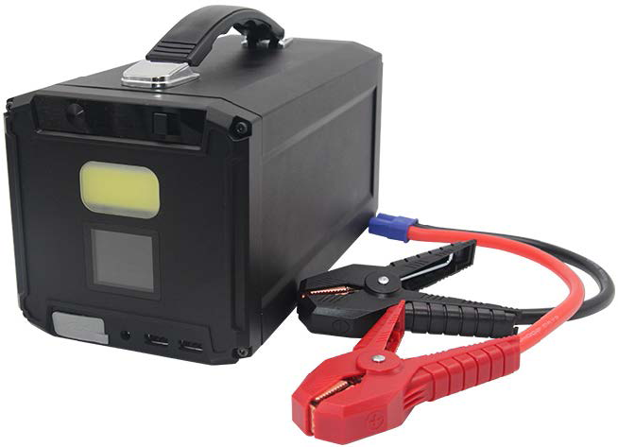

**CONTENTS**

1. Important Notes:...................................................................... 2
2. A4800 Layout:.............................................................................3
3. Specifications..............................................................................4
4. Operation Guidance..................................................................4

A. Jump-starting 12V and 24V engines.................................4

B. Charging Electronic Devices............................................... 6

C. Using the COB Lights............................................................6

1. Maintaining the A4800……………....................................... 6

A. Charging the A4800.............................................................. 6

B. Storing the A4800.................................................................. 7

1. Toxic and harmful substances.................................................7
2. Warning........................................................................................ 8
3. Trouble shooting........................................................................ 9
4. Compliance

**Important Notes**

1. After unpacking the A4800, immediately charge it to 100% battery power before attempting to jump-start an aircraft or other engine.
2. Charge only when temperatures are between 0°C and 40°C
3. Only charge the device with supplied DC adapter.
4. The default mode for A4800 is 12V output. **Must** remember to press and hold the start button for 3 seconds to switch to 24V output when jump-starting 24V vehicles.
5. **Do not** jump-start 12V engines and 24V engines at the same time. **Must** turn off A4800 after jump-starting 12V (24V) , wait for five minutes and turn on A4800 to jump-start 24V (12V) again
6. When the A4800 is less than 75% capacity, do not use it to jump-start a vehicle. However, it can still be used to charge a digital device or for LED lighting
7. **Do not** use the A4800 to charge a digital device for extended periods (in nonemergency situations) as the battery’s power may fall below 75% and be unable to jump start a vehicle in an emergency.
8. The **Red** clamp must be connected with the **positive (+) terminal**, while the **black** one with **negative (-) side**. Do not connect the **red** and **black** clamps together, it may cause an accident.
9. *** Please **remove the clamps from the battery within 15 seconds** after the car is started and the countdown timer has zeroed out, it may cause an accident.
10. When starting the vehicle continuously if more than 2 times (allow **at least 45 seconds pause** between each crank, longer the pause, the better). If the vehicle does not start after 2 attempts, stop trying to start the vehicle and disconnect the device, to avoid damaging other parts of the vehicle.
11. **Do not** recharge the A4800 immediately after you just used the device to jump-start a vehicle. Please wait at least 30 minutes to ensure that the device has cooled down already.
12. To make sure that the A4800 can be used normally in emergency, please check the balance capacity every 6 months and recharge it if the battery level is below 75%.
13. Store the A4800 indoors with the temperature is between -20°C and 60°C.

**A4800 LAYOUT**

|  |
| --- |
|  |
|  |

**Protections:**

**Over Charge / Under Voltage / Reverse Polarity / Over Discharge / Over Current / Short Circuit / Low Voltage**

**Specification :**

|  |  |
| --- | --- |
| Capacity: | 48000mAh/177.6Wh |
| Size: | 240X143X130mm(L/W/H) |
| Weight: | 2.56 kgs |
| Input: | 16.8V/2A |
| DC Output : | 12V/24V (Jump Start) |
| Output 1:  Output 2: | USB1 - 5V/2.1A  USB2 - **QC3.0** 24W(5V/3A;9V/2A;12V/2A) |
| Cigar Port Output : | Cigar Port (12V/10A) |
| Starting current: | 12V/1200A;24V/1000A |
| Peak current: | 12V/2500A;24V/2000A |
| Full charging time: | About 4~5 hours |
| Operating temperature: | -20°C ~ +60°C |
| Storage temperature: | 0°C ~ +40°C |

**Operation Guidance**

**A.Jump-starting 12V and 24V engines**

**Note: Keep the jump-start switch at "OFF" when not in use.**

**Note: Remove the key from the ignition and turn off all electronic devices (radio, lights, etc.) before operation.**

**Note: The A4800 needs to be placed on a flat/level surface. Never put the A4800 in a place where it can be dropped or damaged.**

**Before jump-starting a vehicle, please confirm that the battery voltage is 12V or 24V. Then follow below steps:**

|  |
| --- |
| **(1) (2) (3) (4) (5) (6)** |

**1. Jump-starting 12V vehicles/aircraft :**

(1).Press the **power button** and make sure there are **at least 3 bars of power indicator light.**

(2).Slide the **jump-start switch** to position "**12V**".

(3).Attach the two jumper cables to the battery posts* on the vehicle: **red clamp to the positive (+) terminal and black to the negative (-) terminal.** The vehicle’s battery posts should be free of corrosion and secured tightly.

(4).There is a beep sound of A4800, and the **30 second** timer on the LCD screen will begin to count down. * Does not need to detect a battery to jumpstart engine

(5).Start engine

(6).Once the engine has been started, please remove the cable connector from A4800 first, and then disconnect the clamps from the battery within 15 seconds.

(7).The A4800 has an intelligent shutdown, it will shut down automatically when there is no power loading connection in 30 seconds.

**2. Jump-starting 24V vehicles/aircraft;**

(1).Press the **power button** and make sure there are **at least 3 bars of power indicator light.**

(2).Slide the jump-start switch to position "**24V".**

(3).Attach the two jumper cables to the battery* posts: **red clamp to the positive (+) terminal and black to the negative (-) terminal.** The battery posts should be free of corrosion and secured tightly.

(4).A4800 beeps if battery detected,, and the **30 second** timer on the LCD screen will begin to count down. * Does not need to detect battery to jumpstart engine

(5) Start engine.

(6).Once the engine has been started, please remove the cable connector from A4800 first, and then disconnect the clamps from the battery within 15 seconds.

(7).The A4800 has an intelligent shutdown, it will shut down automatically when there is no power loading connection in 30 seconds.

**3. Do not jump-start 12V and 24V vehicles one by one immediately. Must turn off A4800 after jump start FIRST 12V(24V) vehicle, wait for 5 minutes and then follow the above steps to jump start NEXT 24V(12V) vehicle.**

**B. Charging Electronic Devices**

1. Press the power button of the A4800. This will turn on the screen and activate the USB ports and 12-volt outlet (cigarette lighter adapter).
2. Connect your device(s). Follow the directions for your electronic device(s) to charge safely
3. After charging your electronic device(s), disconnect from the A4800. Check the battery level of the A4800, and recharge the A4800 if it is below 50%. Do not charge the A4800 while you have any device connected with it.
4. The A4800 has an intelligent shutdown, it will shut down automatically when there is no power loading connection in 30 seconds.

**C. Using the COB Lights**

1. Slide the **jump-start switch** to "**OFF**". Then press the **power button** to turn on the screen.
2. Double-click the **power button**. This will turn on the **COB** lights. You can then cycle through the light options in sequence: from the solid lights, click the **power button** to go to flashing lights, then click again to go to SOS pattern lights, then click again to turn the lights off.
3. You can also turn the lights off at anytime from anywhere in the sequence by double clicking the **power button**.
4. Once you finished using the lights, check the battery level of the A4800. Please recharge the A4800 if it is below 50%.
5. The A4800 has an intelligent shutdown, it will shut down automatically when there is no power loading connection in 30 seconds.

**MAINTAINING THE A4800**

**A. Charging the A4800**

**NOTE:** Disconnect any devices from the USBs or Cigar port before charging the A4800.

**NOTE:** If the A4800 has just been used to jump-start a vehicle, wait at least 30 minutes to allow the unit to cool down before re-charging.

**NOTE:** The A4800 can only be charged in the room temperatures from 0°C to +40°C.

**Charging Steps:**

1. Plug the supplied A4800 DC power adapter into the charge port on the front of the unit (below the LCD screen), and plug the power supply cord into an outlet.
2. The green power indicator on the LCD screen will begin to show that the battery is charging. The battery may take up 5 hours to fully charge.
3. When the A4800 is fully charged, a green light on the charging cable box will turn on, and the charging process will automatically stop. Disconnect the K4800 from the power adapter when not in use.

**B. Storing the A4800**

**NOTE:** Store the A4800 away from children to avoid accidents.

**NOTE:** Keep the A4800 away from sources of fire or water, and store in a noncorrosive environment.

1. Store the A4800 on a flat, dry surface.
2. The A4800 can be stored either indoors or in a vehicle provided that temperatures remain between -20°C and 60°C depending on the season, temperatures can easily drop above or below that range inside of a vehicle, so move the A4800 to indoor storage if this is the case.
3. If you are storing the A4800 in a vehicle, ensure that it is secured and will not be damaged during travel

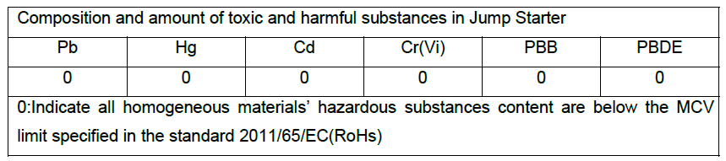

**Toxic and harmful substances**



1. If the A4800 over heats when charging or in storage, please stop use of the A4800, and let it to cool down first.
2. If any damage happened on the A4800, **please stop use of it immediately.**
3. **Do not** attempt to decompose or recycle this product without contacting your local waste management / recycling center for the instructions of where and how to dispose it properly.
4. Please keep A4800 out of the reach of children to avoid accidents/potential safety issues.
5. Always be cautious and alert when using the A4800.
6. Please store and keep out of the reach of children.
7. **Do not** use A4800 as a toy or modify its components for other uses.
8. **Do not** let A4800 sit in wet conditions. The unit must be completely dry to operate. Please protect it from rain, snow, and other elements while in use and while being stored.
9. **Do not** store or use the A4800 in places with moisture or water.
10. **Do not** operate the device in explosive atmospheres, such as in the presence of flammable liquids, gases or dust.
11. **Do not** modify or disassemble A4800, otherwise **will void the warranty and may cause physical danger.** Only a qualified technician can repair K4800.
12. **Do not** expose the A4800 to heat directly.
13. Only using the original home charger to recharge the A4800.
14. If any liquid from the A4800 splash into your eyes, do not rub eyes, just wash with water and contact the doctor.
15. Disconnect USB devices before charging the A4800.
16. **Ensure** the room temperature is at 0°~ 40°C when charging.

**Troubleshooting**

1. **If the "PROTECTIONS" alarm is activated (beep sound) and showed on the LCD display, please check following :**

* Check if there is short-circuit between two clamps, that has triggered short-circuit protection.
* Check if two clamps are reversely connected, that has triggered reverse polarity protection.
* Check if the power indicator is less than 3 bars, that has triggered low voltage protection.
* Check if the clamps are not connected tightly, or the battery is rusted, that may cause higher resistance of circuit and result the low voltage of jump-starter battery, to trigger the over-discharge protection.
* Check if the battery of the vehicle has exceeded the designed specification of the A4800, that may trigger over-charge protection.
* Eliminate above situations and attempt to jump-start again.

1. **No beep sound and 30 second timer is not showed on the LCD screen after clamps are properly connected :**

* First check if clamps are firmly connected to the battery terminals. Then check if the circuit is activated (e.g. some cars would require the key to be turned to "ACC")

1. **Power indicator and battery voltage on the LCD display keeps flashing and the output of USB ports and cigar port are not activated :**

* Slide the jump-start switch to "OFF" to enable the USB ports and cigar port output.

1. **The warning beep from A4800 continuously and power indicator keeps flashing** :

* The A4800 temperature has exceeded 60°C which has triggered over-heat protection. Wait the device to cool off before next attempts.

1. **Power indicator keeps flashing, no output on USB ports and cigar port, also the COB light cannot be turned on.**

* The battery cell is over-charged or over-discharged. Please stop use immediately.

**COMPLIANCE**

**Testing:**

**The AeroJump was tested to the following safety regulations per;**

**IEC61960:2011**

**UN38.3**

**CE / EU Consumer Safety regulations**

**Not considered Hazardous for shipping under HMR 172.101 < 300Wh**