Aero Jump Starter User Manual

Model A3000

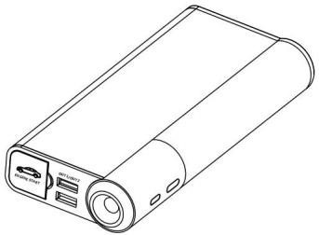

Before using the product, please read this instruction manual carefully and follow the operating instructions to use the product correctly…… **AEROLITHIUM.COM**

# Product Function Detailed Description Diagram

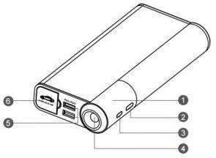



1. Display Screen

4. LED Illumination Light



2. Power Button

5. USB Output Port Port



3. Charging Input Port

6. Car Start Output

**Product Function Overview**

1. Supports charging of mobile phones, tablets, etc.
2. Supports emergency start of 12V vehicle battery when it is low.
3. Supports LED illumination, including high-intensity flash, SOS distress signal, and other

emergency lighting modes.



4. Supports screen display for clear and concise information prompts.

# Product Detailed Accessories Diagram

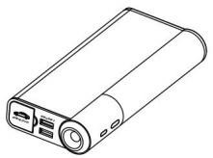

K3000

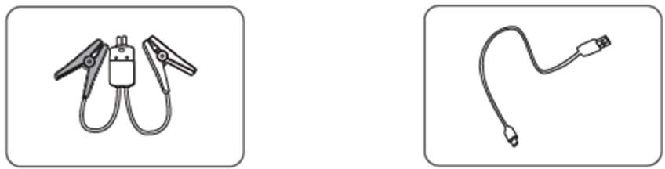

Battery Clamps ( other connections avail ) USB charging Cable

# Function Operation Instructions



**1 . Product Charging Operation**

Plug the USB cable into the charging input port of the product and the USB 5 V/ 2 A power adapter output port. The product will start charging, and the battery icon on the display

screen will flash in a loop. When the battery icon displays 4 bars, it indicates a full charge.

**Note:** The power adapter is an optional accessory. You can also use a phone charger that

* 1. Connect the smart jump start cable to the output port of the product. Note: Ensure that the smart jump start cable are securely inserted.



**2. Engine Start Operation**

* 1. Connect the red clamp of the included smart jump start cable to the positive(+) terminal of the battery, and the black clamp to the negative (-)terminal. **Push and hold button on cable module for 3 seconds to enable Forced Start feature for starting without battery connection. Green light will remain ON for 30 seconds to start engine.**
  2. Once correctly connected, you can proceed with the vehicle start operation.
  3. After the engine is started, detach the smart jump start cable from the start output port of the product, and then remove the red and black clamps from the vehicle battery. (It is recommended to complete step d within 30 seconds after the vehicle start).

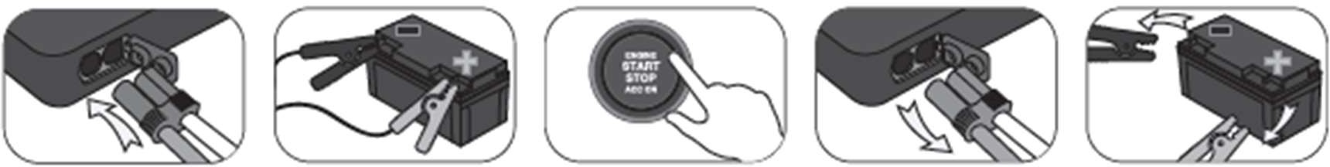

**Friendly reminders:**



a. To ensure optimal starting performance, please make sure that the product has

sufficient battery power (at least 3 bars) before starting the vehicle, and ensure that all electrical devices in the vehicle are turned off.

b. Ensure that the battery clamps are securely and firmly in contact with the battery terminals, as a larger contact area facilitates better current conduction and enhances starting performance.

3. Turning on the LED light

Press and hold the Power Button for 2 seconds to power on the device. Press the power button twice in quick succession to turn on the light.

Press the LED Illumination Button again to switch between high brightness, strobe, and SOS modes. Press the LED Illumination Button twice in quick succession to turn off.



**4. Turning on the USB output:**

Press and hold the Power Button for 2 seconds to power on the device.

Once powered on, you can connect your phone, tablet, or other devices to the USB output port using a charging cable to start charging them.



**5. Turning off the device:**

This product has power-saving management functionality. After detecting no power output, it will enter power-saving mode and automatically shut down after 30 seconds.

# Technical specifications

|  |  |
| --- | --- |
| Battery Capacity | 12,000 mAh 44.4 Wh |
| Start / Pulse Current | 400A / 800A |
| Input | 5V/2A (current range 0.5A-2A） |
| Charging Time | 2 to 5 hours depending on discharge |
| USB Output | 5V/1.0A；5V/2.0A |
| Operating Ambient Temperature | - 30℃ ~ +85℃ |
| Dimensions | 182.4*82*31mm |

**Troubleshooting**

|  |  |  |
| --- | --- | --- |
| Problem | Cause | Troubleshooting Method |
| No response when pressing the switch button. | Low voltage protection. | Plug the charger into  the input port to activate. |

**Toxic and hazardous substances or elements in the product and their contents :**

|  |  |  |  |  |  |  |
| --- | --- | --- | --- | --- | --- | --- |
| Product Name | Toxic and harmful substances or elements | | | | |  |
| Lead(Pb) | Mercury(Hg) | Cadmium(Cd) | Hexavalent  Chromium Cr (VI) | Polybrominated Biphenyls (PBB) | Polybrominated  Diphenyl Ethers (PBDEs) |
| Inflatable  Car Jump Starter | O | O | O | O | O | O |
| O: Indicates that the content of | | | the hazardous substance | | in all homogeneous materials of | |
|  | | | | | | |
| the component is below the limit requirements specified in the 2011/65/EC (RoHS) standard. | | | | | | |

# Precautions:



1. If the product is not used for a long time, it is recommended to fully charge it at least

once every three months. However it will hold 90% charge after one year.



malfunction.

2. During use or charging, if the product generates slight heat, it is normal and not a



1. If the vehicle needs to be attempted to start multiple times, there should be a minimum interval of 60 seconds between each start attempt. If the vehicle cannot start after 3-5

attempts, it is recommended to further check for other faults in the vehicle.

1. Do not touch both ends of the battery clamps together during operation, as it may pose a safety risk.



5. Do not reverse the positive and negative terminals of the battery clamps with the

vehicle's positive and negative terminals, as it may pose a safety risk.



6. Do not disassemble or modify the device to avoid damage or safety risks and voiding

the warranty.

1. Keep the product out of reach of children and store it properly.
2. To ensure optimal charging performance, use a power charger ( 5 V/ 2 A) manufactured by a reputable manufacturer to charge the product.

environments to mitigate safety risks:



9. It is recommended to use this product in a safe environment and avoid the following

* 1. Damp areas and places prone to water splashes.
  2. Places with high temperatures, open flames, corrosive substances, or chemical gas

hazards.

* 1. Places with mud or sand.
  2. Places prone to falling.
  3. Places where flammable or explosive materials are stored.
  4. Places with severe vibrations or impacts.